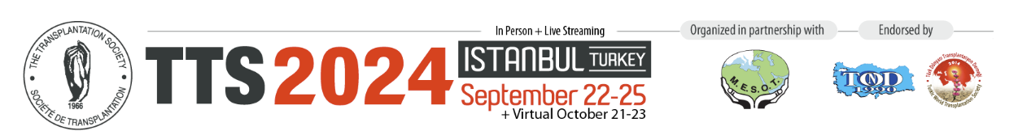
Dear ABTO Member,
The 30th International Congress of The Transplantation Society (TTS 2024 - www.tts2024.org) is scheduled to take place in Istanbul, Turkey, from September 22-25, 2024. The meeting is being held in person; however, there is a virtual streaming option for those unable to travel.
We have planned an exciting Congress with renowned speakers, new session types, and ample time to network. You can preview the program here: https://app.tts2024.org/virtual/programme/2024-09-22.
One of the core Congress commitments was to make the meeting as affordable as possible for Early Career Members. As such, TTS 2024 is offering many awards, significant registration fee discounts for Trainees and Fellows, lower-cost hotel options, and a 15% discount for travel through Turkish Airlines (www.tts2024.org/travel/official-airline-turkish-airlines). The Congress will also features special rates for established ABTO Members and AHPs.
An important component of every Congress has been the abstract paper submissions for which the deadline to submit is set for March 18, 2024 (https://www.tts2024.org/program/call-for-abstracts). TTS will be sponsoring many awards for the Congress which require an abstract submission:
- TTS Scientific Congress Awards - These awards are designed to help offset expenses incurred to attend the TTS Congress and are awarded based on the scientific merit of applicants (Details: www.tts2024.org/awards/tts-scientific-congress-awards).
Registration and Housing are now open:
- Registration Details: www.tts2024.org/registration/registration-information
ABTO Members will receive the Member (Low to Middle Income Country) rate which of $350 US for Full Members, $100 for Trainees and $175 for AHPs. Simply use the promotional code ABTO2024 when creating a profile.
- Housing Details: www.tts2024.org/accommodation
We hope as many ABTO members as possible submit an abstract and attend TTS 2024 to enjoy this unique opportunity both as a participant and ambassador for the Brazilian Transplant Community.
We look forward to seeing you in Istanbul!
The Transplantation Society
International Headquarters

TTS 2024 Secretariat
- General inquiries: info@tts2024.org
- Program and abstracts: Catherin Parker - program@tts2024.org
- Sponsorship: Kathy Tsandilas - kathy.tsandilas@tts.org
- Registration: Amanda Mayer - registration@tts.org

